Algebra 1: Unit 3, Lesson 8

- A scatter plot with a line of fit is shown.
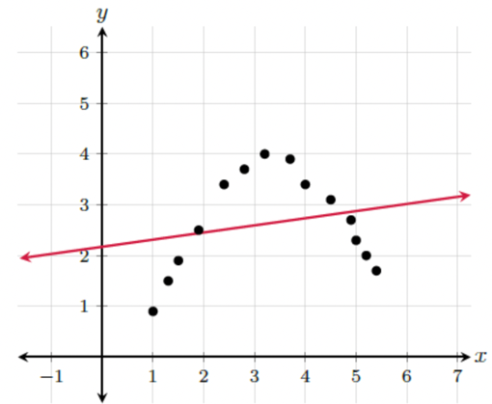
What kind of association is there between the $x$- values and the $y$- values?
Non-linear

- The scatter plot displays the average finishing time for a high school cross country team in the women’s 55-kilometer (km) race for the regional meet since 2001 as shown.
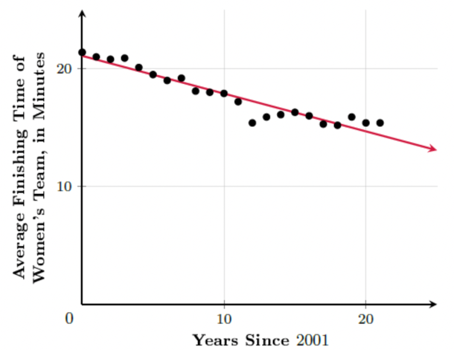
Complete the table to find the missing residual value.
$x$- value | Actual $y$- value | Predicted $y$- value | Residual Value
$$12$$ | $$15.4$$ | $$17.247$$ | _______
-1.847

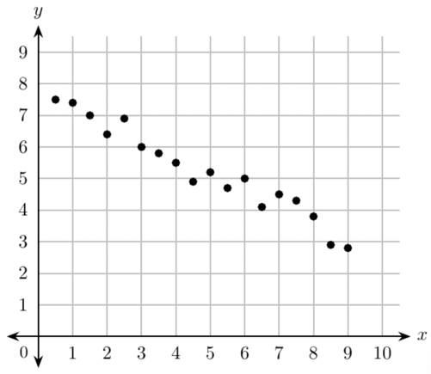
- What kind of association does the scatter plot show?

Strong, negative linear

